Solar PV
Solar panels capture the sun’s energy and convert this into electricity which can be used in your home.

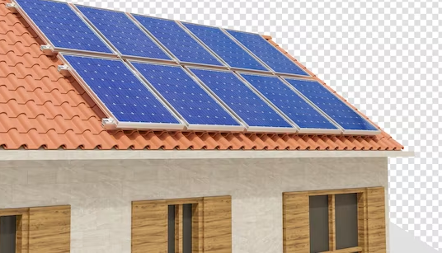
Benefits
Lower Electricity Bills.
Reduce your carbon footprint.
Potential payments for additional electricity generated.

How much roof space is required?
Typically space of 20m2 is required to install solar panels.

What is the installation process and how will this impact me?
Scaffolding will be required to allow safe access to the roof area which may block direct sunlight. Access into your home will be needed once the installation of the panels has been completed to allow an electrical connection to be undertaken.
Work Sequence
Erection of scaffolding.
Panel mounts will be installed to hold the panels in place.
Install solar panels.
Connection electrical wiring – solar inverted wired to consumer unit.
Testing of panels.
Remove scaffolding.

How long will the works take to complete?
The estimated timescale for installation would be 5 working days.

When will I see the benefits of this?
The benefits will be greater during the daytime (year-round). Using the electricity your panels generate will reduce your bills. Savings depend on system size, electricity use, whether you're at home during the day to use the energy you're producing and other lifestyle factors.

