Low Energy Lighting
Replacing light bulbs throughout the home can help lower electricity bills and carbon emissions.
Traditional, halogen or incandescent light bulbs are inefficient in comparison to compact fluorescent lamps (CFLs) and light emitting diodes (LEDs).
Companies are not permitted to manufacture inefficient light bulbs however suppliers and shops are allowed to continue selling their existing stock of these items.
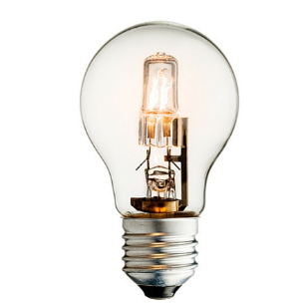
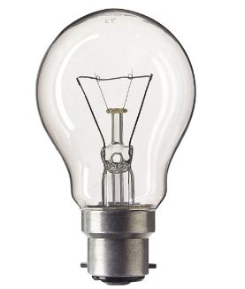

Halogen
Incandescent

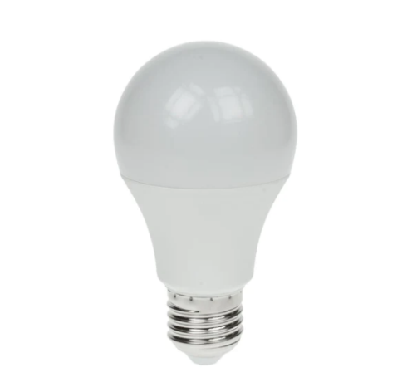
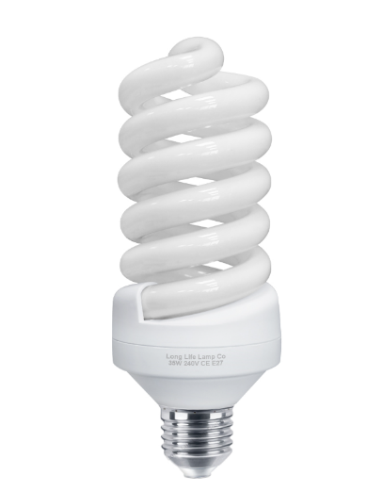

Light emitting diodes (LEDs)
Compact Fluorescent lamps (CFLs)

Ventilation – Trickle Vents, Door Undercuts, Extractor Fans
When undertaking works to retain heat it also necessary to increase air flow. The reason for this is to stop any potential condensation. There are various ways to boost air circulation some of which may be included when undertaking energy improvement works to your home.
Trickle Vents – most new windows come with trickle vents already installed however these can also be easily fitted later. They help keep air in the home fresh and clean as well as keeping condensation out and lowering humidity.
Door undercuts – Internal doors should have at least a 10mm high undercut to allow air flow between rooms even when doors are closed.
Extractors Fan – The purpose of an extractor fan is to pull hot air from humid places within the home and direct it outside via a duct. They are usually located near kitchen appliances, bathrooms, washing machines, dishwashers, tumble driers or other areas that become exposed to excess moisture due to steam or water.

Hot Water Cylinder Jacket
A poorly insulated hot water tank will lose its heat quickly this will result in more energy having to be used to create additional hot water. An effective jacket should be at least 80mm thick to maximise efficiency. We will also lag the hot pipe work up to 1.5m around the cylinder.

Weather Compensator / Heating Control Upgrade
Fitting a weather compensator to a gas boiler will regulate the usage and prevent wasted energy. The device will monitor indoor and outdoor temperatures and tell your boiler to use just enough gas to maintain your desired temperature. This will help lower both your carbon footprint and fuel costs.

